**curl:**

curl is generally used to communicate with the server and also used to transfer the data from server to client

Command : curl <option> <Websitelink>

there are various option can be used along with curl command.They are

-o ==> which is used to save the data of website in our local files

Syntax :curl -o <Local_File_Name> <WebsiteLink>

-O ==> which is used to save the data from server directly locally without creating local file explicity.Which means it creates file with website name and saves into it.

-s ==>silent mode.Generally when we use curl command the output will be data and also progress bar which shows how much amount data is transferred.In order to avoid to progress bar we use -s option.

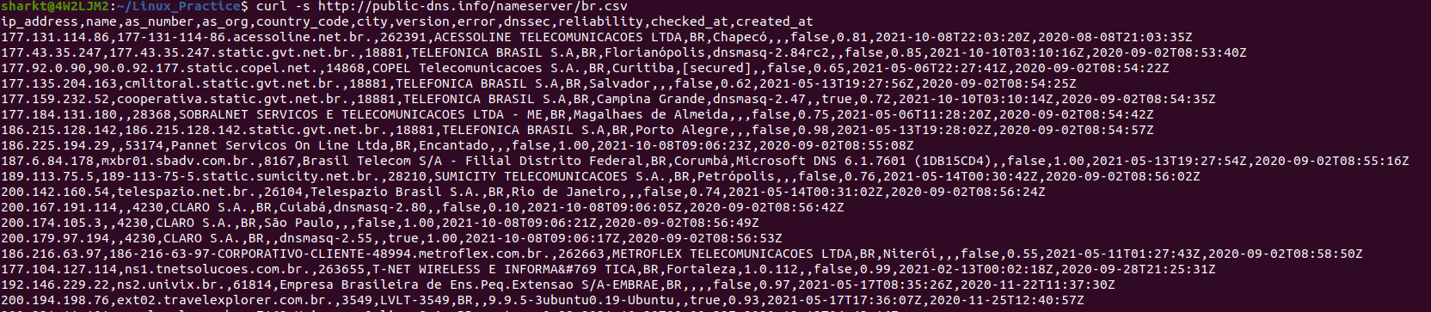**Cut:**

cut command is used to cut the specific content from file and show output on GUI.It is used to cut specific sections by mentioning byte position,character and field

Syntax: cut <options> <File_Name>

-f ==> this is option used to get specfic fields or columns my mentioning column number

-d<Delimiter> ==> this is used to get specfic data by providing delimeter .It can be used -f option to get specfic data before delimiter or after delimiter

Syntax :: cut -d - -f2 <FileName>

which gives output as show content separated by hyphen and 2nd column

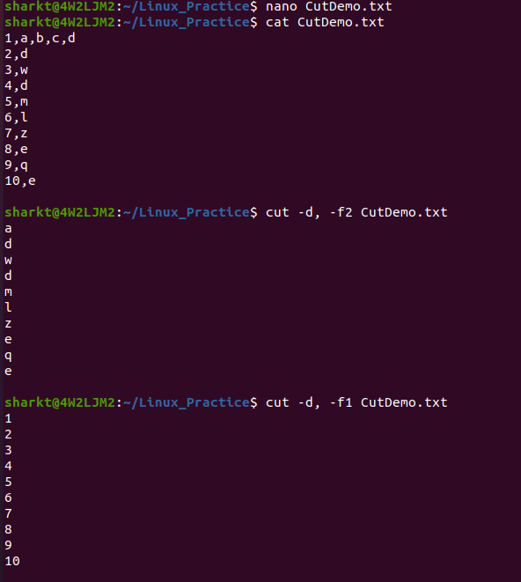

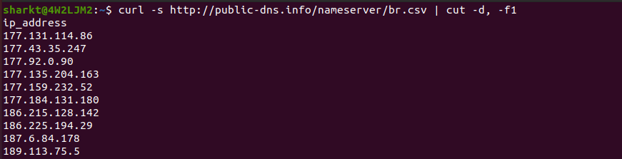

**Shuf:**

Shuf command:shuf command is used to shuffle the data in a file i.e when there is 1 to N are there in a file ,when we use shuf with file name then all those numbers will be shuffled

Syntax :shuf <option> <filename>

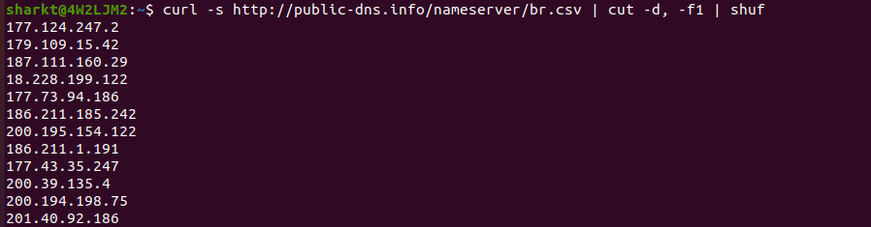

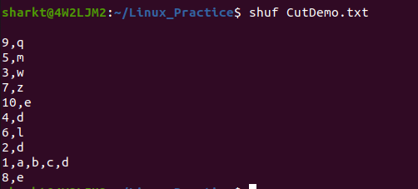

**Tail**:

Tail command used to get the last ten lines of code or data from the specified file.By default we get last ten lines code.

Syntax: tail <option> <File_Name>

-n ==> if we want to specficially print last lines then we need to mention number so that it will print

specified lines of code.

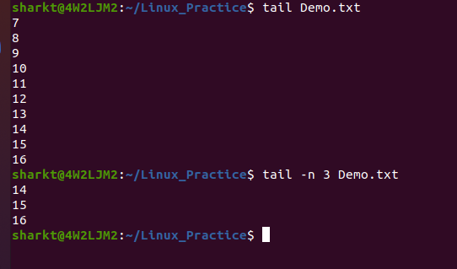

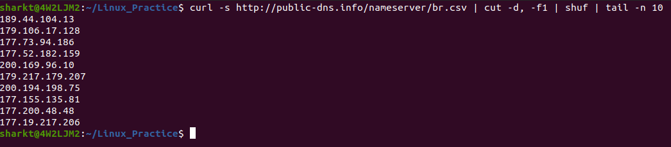

**Xargs:**

xargs command executes command lines which means it takes the output of a command and passes it as argument of another command

Syntax:xargs <option> command

-a ==> Read items from file instead of standard input

cat deletefile.txt | xargs rm

here deletefile contains files which are deleted .that cat command output will passed to xargs as input and removes those files.

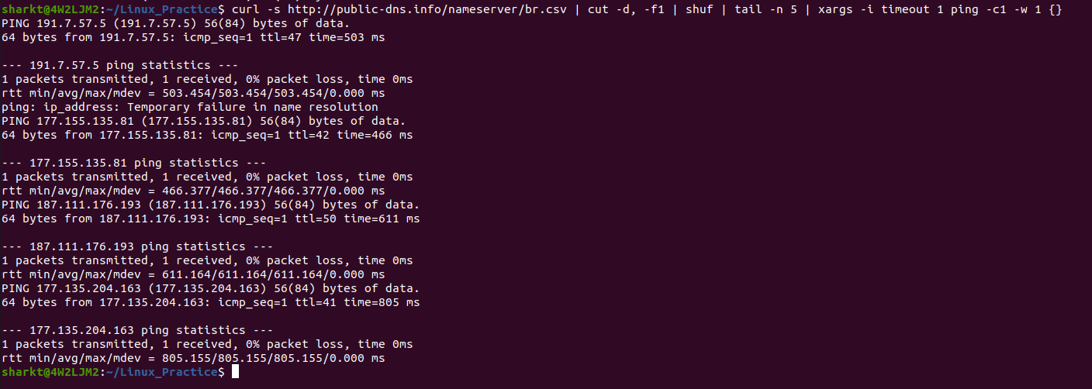**Grep:**

grep command used to find or filter the content from a file.Generally it used to find patterns specified by user.

Syntax :: grep <patterntofind> <file name

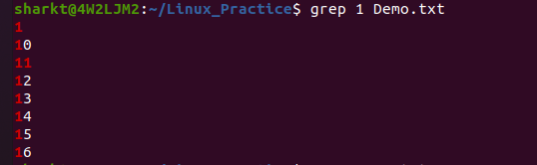



**awk:**

awk is a scripting language used to write statements defining specific patterns to be searched for each line of a file and the action which is to be taken when a match is found within a line.

Syntax:: awk <option> filename

awk uses various commands .one of them is called “substr “ which is used to select a substring from the input

Syntax : substr(s,a,b) ==>It returns b number of characters from string s ,starting at position a.

Example awk ‘{print substr($1,1,1) data.txt

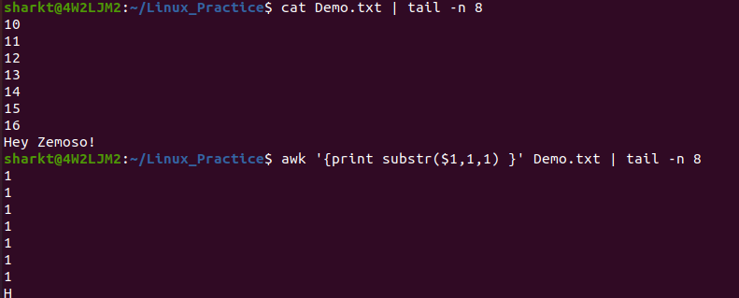



**sort:**

sort command used to sort the data of file in ascending or decending order.By default it sorts in ascending order

syntax : sort <option> <Filename>

-n ==> This option used to sort based on numerals

-k ==> This option used to sort based on columns

-r ==>sort in descending order

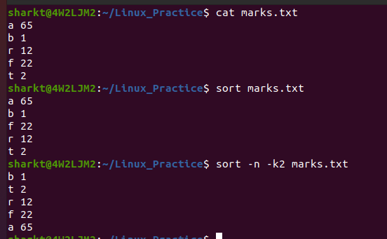



**Head:**

Head command used to get the first ten lines of code or data from the specified file.By default we get first ten lines code.

Syntax: tail <option> <File_Name>

-n ==> if we want to specficially print first lines then we need to mention number so that it will print specified lines of code.

